Initial Project Setup

1. Once you have the solution downloaded, you will need to open up the demo folder then double click the ‘Demo.sln’ file.
2. Once Visual Studio is open and the project is loaded, you will need to make sure the project builds correctly. To do this you will need to select 'Build' on the upper right menu bar and then select 'Build Solution'.
   1. 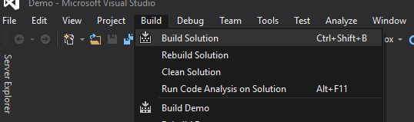
   2. The reason you build the solution first is to make sure that everything got download, and when the solution builds for the first time on a new computer it will download and install any missing Nuget packages that are needed.
3. Then go to the 'Tools' menu option and under 'Nuget Package Manager' select 'Package Manager Console'. A new pop up should appear, on mine it showed up at the bottom of Visual Studio.
   1. 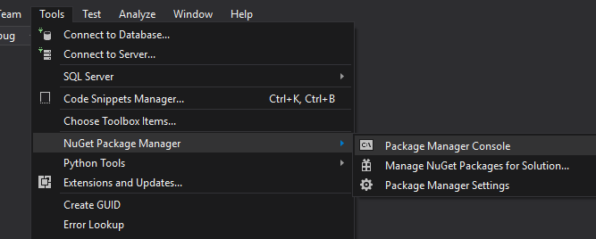
4. In the pop up that appeared type in 'update-database' next to ‘PM>’.
   1. 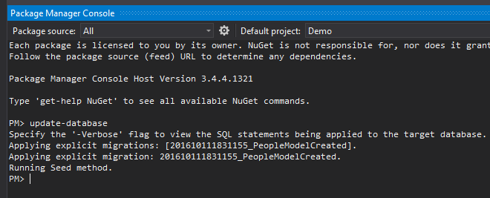
5. Once you have done all you are now complete. You will now be able to run the program by pressing 'F5' or clicking on the green play button at the top of the screen.
   1. 